**R444A01 modbus rtu protocol**

Function code

|  |  |  |  |  |
| --- | --- | --- | --- | --- |
| RS485 address  (Station address)  (1) | Function (1) | Register address (2) | Read number (2) | CRC16 (2) |
|  | 03 Read |  |  |  |
|  | 06 Write |  |  |  |

|  |  |  |  |  |
| --- | --- | --- | --- | --- |
| Read-only register,Read Function code Is 03 | | | | |
| Register address | Register contents | Number of bytes | Units | Remarks |
| 0x0000 | Temperature value | 2 | 0.1℃ | When the data is 0X8000, it indicates sensor error |
| 0x0001 | Humidity value | 2 | 0.1%RH |
| Read / write register; Read function code is 03 ,Write function code is 06 | | | | |
| 0x0002 | RS485 address  (Station address) | 2 |  | Read Address 0XFF  Write Address 1-247 |
| 0x0003 | Baud rate | 2 |  | 0~4 0:1200  1:2400 2:4800  3:9600（default）  4:19200 |

**Serial baud rate：9600（**default**），N，8，1**

**Modbus RTU Communication protocol：**

1. **Read temperature**

Send data

|  |  |  |  |  |
| --- | --- | --- | --- | --- |
| RS485 address  (Station address)  (1) | Function (1) | Register address (2) | Read number (2) | CRC16(2) |

Returns data

|  |  |  |  |  |
| --- | --- | --- | --- | --- |
| RS485 address  (Station address)  (1) | Function (1) | Number of bytes (1) | data (n) | CRC16(2) |

Function code 0x03

Register address：0x0000

Read number：0x0001

The return of the temperature data is two bytes，High-bit in the former and low-bit in the post，convert it to decimal and divided by 10, is the current temperature value；The highest bit 1 indicates a negative value， this value directly subtracting 65536，is the current temperature value.

For example:

send data(RS485 address is 1)：01 03 00 00 00 01 84 0A

Returns data：01 03 02 00 DB F8 1F

01 RS485 address，03 Function，02 length，F8 1F crc16

00DB is the temperature value, the highest bit is 0, so the temperature is positive, it is converted to decimal = 219, 219/10=21.9 is the current temperature value；

Returns data：01 03 02 FF 90 F2 3F

FF90 is the temperature value, the highest bit is 1, so the temperature is negative, it is converted to decimal = 65424, (65424-65536)/10=-11.2 is the current temperature value

1. **Read Humidity**

Send data

|  |  |  |  |  |
| --- | --- | --- | --- | --- |
| RS485 address  (Station address)  (1) | Function (1) | Register address (2) | Read number (2) | CRC16(2) |

Returns data

|  |  |  |  |  |
| --- | --- | --- | --- | --- |
| RS485 address  (Station address)  (1) | Function (1) | Number of bytes (1) | data (n) | CRC16(2) |

Function code 0x03

Register address：0x0001

Read number：0x0001

The return of the Humidity data is two bytes，High-bit in the former low-bit in the post，convert it to decimal and divided by 10, is the current temperature value；

For example:

send data(RS485 address is 1)：01 03 00 01 00 01 D5 CA

Returns data：01 03 02 02 32 38 F1

01 RS485 address，03 Function，02 length，38 F1 crc16

0232 is the Humidity value, it is converted to decimal = 562, 562/10=56.2 is the current Humidity value；

1. **Read RS485 address**

Send data

|  |  |  |  |  |
| --- | --- | --- | --- | --- |
| RS485 address  (Broadcast address)  (1) | Function (1) | Register address (2) | Read number (2) | CRC16(2) |

Returns data

|  |  |  |  |  |
| --- | --- | --- | --- | --- |
| RS485 address  ( Broadcast address )  (1) | Function (1) | Number of bytes (1) | data (n) | CRC16(2) |

Broadcast address 0xff

Function code 0x03

Register address：0x0002

Read number：0x0001

For example:

send data：FF 03 00 02 00 01 30 14

Returns data：FF 03 02 00 01 50 50

FF Broadcast address，03 Function，02 length，01 is the current module RS485 address , 50 50 crc16

Note: When using this command, only one temperature module can be connected to the RS485 bus, more than one will be wrong!

1. **Write RS485 address**

Send data

|  |  |  |  |  |
| --- | --- | --- | --- | --- |
| RS485 address  (Station address)  (1) | Function (1) | Register address (2) | Setting Content (2) | CRC16(2) |

Returns data

|  |  |  |  |  |
| --- | --- | --- | --- | --- |
| RS485 address  (Station address)  (1) | Function (1) | Register address  (1) | Register value (2) | CRC16(2) |

Function code 0x06

Register address：0x0002

Setting Content：2Bytes(1-247)

For example, The current RS485 address is 1, We need to change the RS485 address to 3:

send data(RS485 address is 1)：01 06 00 02 00 03 68 0B

Returns data：01 06 00 02 00 03 68 0B

1. **Read baud rate**

Send data

|  |  |  |  |  |
| --- | --- | --- | --- | --- |
| RS485 address  (Station address)  (1) | Function (1) | Register address (2) | Read number (2) | CRC16(2) |

Returns data

|  |  |  |  |  |
| --- | --- | --- | --- | --- |
| RS485 address  (Station address)  (1) | Function (1) | Number of bytes (1) | data (n) | CRC16(2) |

Function code 0x03

Register address：0x0003

Read number：0x0001

For example:

send data(RS485 address is 1)：01 03 00 03 00 01 74 0A

Returns data：01 03 02 00 03 F8 45

01 RS485 address，03 Function，02 length，38 F1 crc16

03 means the current baud rate is 9600bps

Baud rate corresponds to the number: 0: 1200 1: 2400 2: 4800 3: 9600 4: 19200

1. **Write RS485 address**

Send data

|  |  |  |  |  |
| --- | --- | --- | --- | --- |
| RS485 address  (Station address)  (1) | Function (1) | Register address (2) | Setting Content (2) | CRC16(2) |

Returns data

|  |  |  |  |  |
| --- | --- | --- | --- | --- |
| RS485 address  (Station address)  (1) | Function (1) | Register address  (1) | Register value (2) | CRC16(2) |

Function code 0x06

Register address：0x0003

Setting Content：2Bytes(0-4)

For example, Change the baud rate to 4800bps:

send data(RS485 address is 1)：01 06 00 03 00 02 F8 0B

Returns data：01 06 00 03 00 02 F8 0B

Baud rate corresponds to the number: 0: 1200 1: 2400 2: 4800 3: 9600 4: 19200

Note: The baud rate will be updated when the module is powered up again!

MODBUS commands you can use "Modbus Poll" input, as shown below

（CRC check generated automatically）

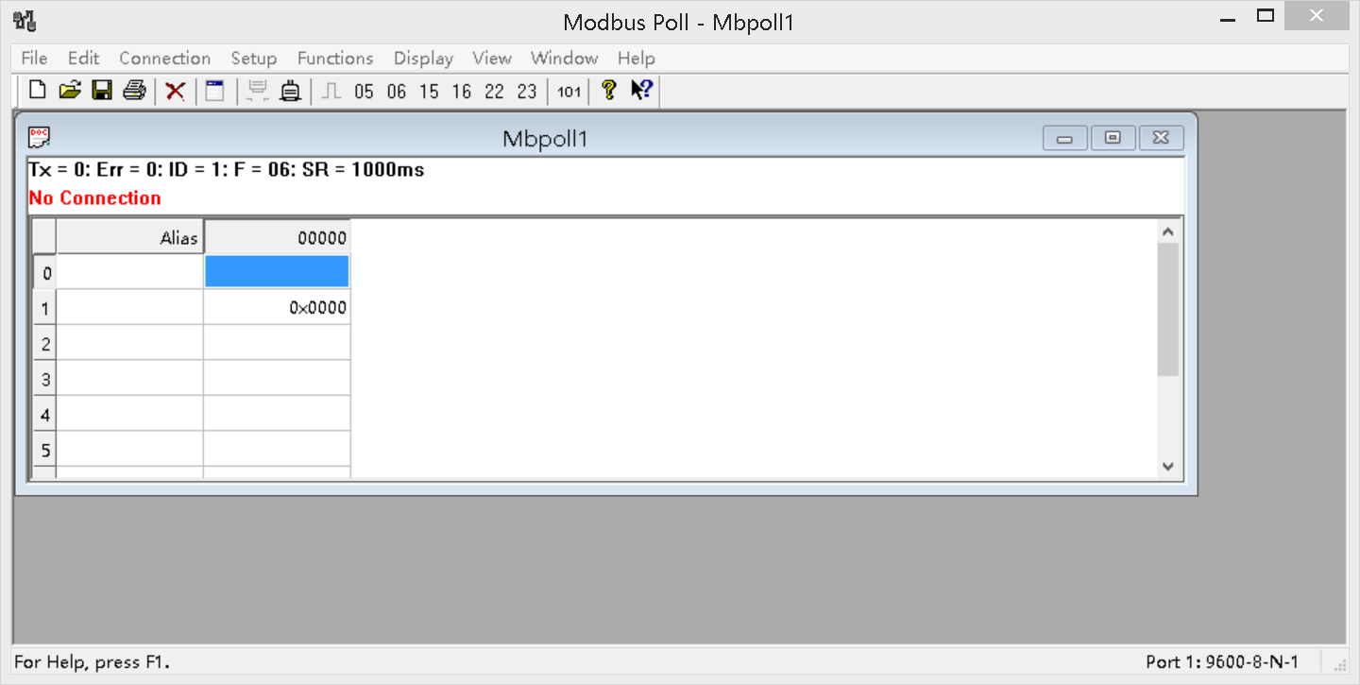

You can also use HyperTerminal serial input, as shown below

（Manually add CRC check）

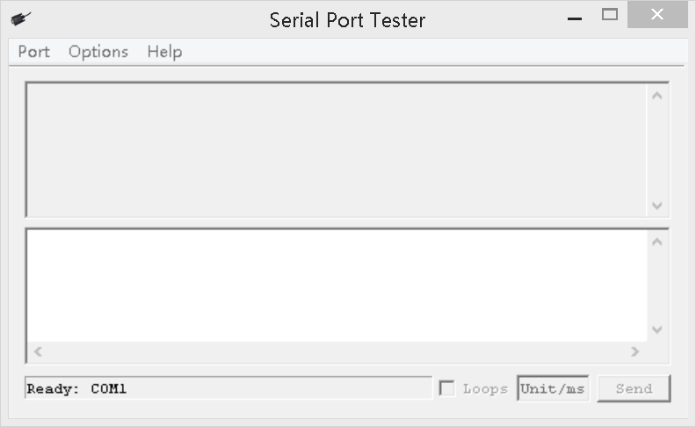

**CRC check code(C51 MCU)：**

const unsigned char code auchCRCHi[256] = {

0x00, 0xC1, 0x81, 0x40, 0x01, 0xC0, 0x80, 0x41, 0x01, 0xC0, 0x80, 0x41, 0x00, 0xC1, 0x81, 0x40,

0x01, 0xC0, 0x80, 0x41, 0x00, 0xC1, 0x81, 0x40, 0x00, 0xC1, 0x81, 0x40, 0x01, 0xC0, 0x80, 0x41,

0x01, 0xC0, 0x80, 0x41, 0x00, 0xC1, 0x81, 0x40, 0x00, 0xC1, 0x81, 0x40, 0x01, 0xC0, 0x80, 0x41,

0x00, 0xC1, 0x81, 0x40, 0x01, 0xC0, 0x80, 0x41, 0x01, 0xC0, 0x80, 0x41, 0x00, 0xC1, 0x81, 0x40,

0x01, 0xC0, 0x80, 0x41, 0x00, 0xC1, 0x81, 0x40, 0x00, 0xC1, 0x81, 0x40, 0x01, 0xC0, 0x80, 0x41,

0x00, 0xC1, 0x81, 0x40, 0x01, 0xC0, 0x80, 0x41, 0x01, 0xC0, 0x80, 0x41, 0x00, 0xC1, 0x81, 0x40,

0x00, 0xC1, 0x81, 0x40, 0x01, 0xC0, 0x80, 0x41, 0x01, 0xC0, 0x80, 0x41, 0x00, 0xC1, 0x81, 0x40,

0x01, 0xC0, 0x80, 0x41, 0x00, 0xC1, 0x81, 0x40, 0x00, 0xC1, 0x81, 0x40, 0x01, 0xC0, 0x80, 0x41,

0x01, 0xC0, 0x80, 0x41, 0x00, 0xC1, 0x81, 0x40, 0x00, 0xC1, 0x81, 0x40, 0x01, 0xC0, 0x80, 0x41,

0x00, 0xC1, 0x81, 0x40, 0x01, 0xC0, 0x80, 0x41, 0x01, 0xC0, 0x80, 0x41, 0x00, 0xC1, 0x81, 0x40,

0x00, 0xC1, 0x81, 0x40, 0x01, 0xC0, 0x80, 0x41, 0x01, 0xC0, 0x80, 0x41, 0x00, 0xC1, 0x81, 0x40,

0x01, 0xC0, 0x80, 0x41, 0x00, 0xC1, 0x81, 0x40, 0x00, 0xC1, 0x81, 0x40, 0x01, 0xC0, 0x80, 0x41,

0x00, 0xC1, 0x81, 0x40, 0x01, 0xC0, 0x80, 0x41, 0x01, 0xC0, 0x80, 0x41, 0x00, 0xC1, 0x81, 0x40,

0x01, 0xC0, 0x80, 0x41, 0x00, 0xC1, 0x81, 0x40, 0x00, 0xC1, 0x81, 0x40, 0x01, 0xC0, 0x80, 0x41,

0x01, 0xC0, 0x80, 0x41, 0x00, 0xC1, 0x81, 0x40, 0x00, 0xC1, 0x81, 0x40, 0x01, 0xC0, 0x80, 0x41,

0x00, 0xC1, 0x81, 0x40, 0x01, 0xC0, 0x80, 0x41, 0x01, 0xC0, 0x80, 0x41, 0x00, 0xC1, 0x81, 0x40

} ;

const unsigned char code auchCRCLo[256] = {

0x00, 0xC0, 0xC1, 0x01, 0xC3, 0x03, 0x02, 0xC2, 0xC6, 0x06, 0x07, 0xC7, 0x05, 0xC5, 0xC4,0x04,

0xCC, 0x0C, 0x0D, 0xCD, 0x0F, 0xCF, 0xCE, 0x0E, 0x0A, 0xCA, 0xCB, 0x0B, 0xC9, 0x09, 0x08, 0xC8,

0xD8, 0x18, 0x19, 0xD9, 0x1B, 0xDB, 0xDA, 0x1A, 0x1E, 0xDE, 0xDF, 0x1F, 0xDD, 0x1D, 0x1C, 0xDC,

0x14, 0xD4, 0xD5, 0x15, 0xD7, 0x17, 0x16, 0xD6, 0xD2, 0x12, 0x13, 0xD3, 0x11, 0xD1, 0xD0, 0x10,

0xF0, 0x30, 0x31, 0xF1, 0x33, 0xF3, 0xF2, 0x32, 0x36, 0xF6, 0xF7, 0x37, 0xF5, 0x35, 0x34, 0xF4,

0x3C, 0xFC, 0xFD, 0x3D, 0xFF, 0x3F, 0x3E, 0xFE, 0xFA, 0x3A, 0x3B, 0xFB, 0x39, 0xF9, 0xF8, 0x38,

0x28, 0xE8, 0xE9, 0x29, 0xEB, 0x2B, 0x2A, 0xEA, 0xEE, 0x2E, 0x2F, 0xEF, 0x2D, 0xED, 0xEC, 0x2C,

0xE4, 0x24, 0x25, 0xE5, 0x27, 0xE7, 0xE6, 0x26, 0x22, 0xE2, 0xE3, 0x23, 0xE1, 0x21, 0x20, 0xE0,

0xA0, 0x60, 0x61, 0xA1, 0x63, 0xA3, 0xA2, 0x62, 0x66, 0xA6, 0xA7, 0x67, 0xA5, 0x65, 0x64, 0xA4,

0x6C, 0xAC, 0xAD, 0x6D, 0xAF, 0x6F, 0x6E, 0xAE, 0xAA, 0x6A, 0x6B, 0xAB, 0x69, 0xA9, 0xA8, 0x68,

0x78, 0xB8, 0xB9, 0x79, 0xBB, 0x7B, 0x7A, 0xBA, 0xBE, 0x7E, 0x7F, 0xBF, 0x7D, 0xBD, 0xBC, 0x7C,

0xB4, 0x74, 0x75, 0xB5, 0x77, 0xB7, 0xB6, 0x76, 0x72, 0xB2, 0xB3, 0x73, 0xB1, 0x71, 0x70, 0xB0,

0x50, 0x90, 0x91, 0x51, 0x93, 0x53, 0x52, 0x92, 0x96, 0x56, 0x57, 0x97, 0x55, 0x95, 0x94, 0x54,

0x9C, 0x5C, 0x5D, 0x9D, 0x5F, 0x9F, 0x9E, 0x5E, 0x5A, 0x9A, 0x9B, 0x5B, 0x99, 0x59, 0x58, 0x98,

0x88, 0x48, 0x49, 0x89, 0x4B, 0x8B, 0x8A, 0x4A, 0x4E, 0x8E, 0x8F, 0x4F, 0x8D, 0x4D, 0x4C, 0x8C,

0x44, 0x84, 0x85, 0x45, 0x87, 0x47, 0x46, 0x86, 0x82, 0x42, 0x43, 0x83, 0x41, 0x81, 0x80,0x40

} ;

unsigned int CRC_16(unsigned char *str,unsigned int usDataLen)

{

unsigned char uchCRCHi = 0xFF ; /* high byte of CRC initialized */

unsigned char uchCRCLo = 0xFF ; /* low byte of CRC initialized */

unsigned uIndex ; /* will index into CRC lookup table */

while (usDataLen--)/* pass through message buffer */

{

uIndex = uchCRCHi ^ *str++ ; /* calculate the CRC */

uchCRCHi = uchCRCLo ^ auchCRCHi[uIndex];

uchCRCLo = auchCRCLo[uIndex] ;

}

return (uchCRCHi << 8 | uchCRCLo) ;

}